Book Alley

Vision Document

Version 1.1

Revision History

| **Date** | **Version** | **Description** | **Author** |
| --- | --- | --- | --- |
| 28/10/2023 | 1.0 | Initial Vision Document | Nguyễn Minh Khôi |
| 16/11/2023 | 1.1 | Revised Vision Document | All member |
|  |  |  |  |
|  |  |  |  |

Table of Contents

**1. Introduction 4**

1.1 References 4

**2. Positioning 4**

2.1 Problem Statement 4

2.2 Product Position Statement 4

**3. Stakeholder and User Descriptions 4**

3.1 Stakeholder Summary 5

3.2 User Summary 5

3.3 User Environment 5

3.4 Summary of Key Stakeholder or User Needs 5

3.5 Alternatives and Competition 6

**4. Product Overview 6**

4.1 Product Perspective 6

4.2 Assumptions and Dependencies 8

**5. Product Features 8**

**6. Non-Functional Requirements 8**

- 3

Vision (Small Project)

# Introduction

- The purpose of this document is to define the high-level requirements of the Book Alley web application in terms of needs of the end user. It focuses on the capabilities needed by the stakeholders and the target users, and why these needs exist. The details of how the Book Alley fulfills these needs are detailed in the use-case and supplementary specifications

- The scope of this project encompasses the development of a user-friendly e-commerce website with features like book listings, secure payment processing, user accounts, and search functionality. It will also involve integrating a content management system for easy book uploads and updates, as well as a robust security system to protect user data. The project may expand to include ebook downloads and a blog section for additional content and engagement.

## References

None

# Positioning

## Problem Statement

| The problem of | People who love to read book have limited access to high quality books and lesser known author struggle to sell their books |
| --- | --- |
| affects | Book enthusiasts, people who have an interest for reading and small, lesser known author |
| the impact of which is | People find ebooks online from unreliable sources. People might pirate books without paying for the author |
| a successful solution would be | To create a website dedicated to selling only books from famous authors and also anyone who have a passion of writing books |

## Product Position Statement

| For | Book enthusiasts, people who have an interest for reading and anyone who has a passion of writing book, novel, etc |
| --- | --- |
| Who | Want to have an easier access to higher-quality books from many aspiring authors or want to sell their books |
| Book Alley | is a website |
| That | Help book lovers easily find their favorite books without much hassle. And also help small author to have an income from their books |
| Unlike | Tiki, Shopee, etc |
| Our product | has a user-friendly interface, easy to navigate, detailed recommendation, book list and book information to ensure that even non technical users can still easily buy our books |

# Stakeholder and User Descriptions

This section describes the user of Book Alley. There are 3 types of user: the Admin, the Seller and the Customer

## Stakeholder Summary

| **Name** | **Description** | **Responsibilities** |
| --- | --- | --- |
| Development team | Work with users and stakeholders to turn their needs into requirement | Responsible for website development, planning, designing, operating and maintenance |
| Supervisors | This stakeholder is the main supporter of the team during the development process | Supervise the hold development process to ensure the website quality is stable |
| Seller | People that sell their self-written books or their old unwanted books | Ensure that the website always has a large variety of books from many genres |

## 

## User Summary

| **Name** | **Description** | **Responsibilities** | **Stakeholder** |
| --- | --- | --- | --- |
| Admin | They’re the website’s administrators and have full authority over the website. | They can add or ban/delete users (customer and seller) and moderate the website | Self |
| Seller | They’re the main supplier of books for the website | Add or create new books on the website for sell | Self |
| Customer | They’re the main consumer of the website | Use the website to find their favorite books to buy | Self |

## User Environment

* Book Alley has a total of 5 people involved in completing the project and no new member will be added into the group
* This project's main target users are book enthusiasts including but not limited to avid readers, students and individuals looking for specific titles or genres.
* As of now, the project is only supported on computers with a network connection. It required a web browser to access
* In the future, this project may be supported by mobile devices with Android, iOS operating system

## Summary of Key Stakeholder or User Needs

| **Need** | **Priority** | **Concerns** | **Current Solution** | **Proposed Solutions** | |
| --- | --- | --- | --- | --- | --- |
| Search | High | User can’t easily find the specific book that they want | The user has to look through all the books available on the app to be able to find the book they wanted | | The user can directly search for any books they want given that they know a portion of the book name or they can search by tags |
| Payment | Medium | Users can’t easily pay for the book that they wanted. | The user can only pay for their book through manual transfer or cash-on-delivery | | The application uses e-banking or third-party services like Momo, Paypal, etc. |
| Responsiveness | Low | The UI of web application on mobile and other handheld device is not friendly | User can only use web browser on computer or laptop for the best experience | | User can use web on all platform (computer, laptop, mobile, smart TV, etc) |

## Alternatives and Competition

* As of now, there multiple of websites that sell books that the users may consider such Amazon Books, BookOutlet, etc
* Amazon Books as an example have an extended inventory of books from many famous authors and from credible sources.
* But they also have a quite confusing interface with many texts such as ads, tons of categories and filters, etc that could be overwhelming for the unfamiliar users.

# Product Overview

## Product Perspective

* The envisioned web application stands at the intersection of technology and literature, aiming to revolutionize the online book retail space by honing in on the unique needs and preferences of book enthusiasts.
* Unlike conventional e-commerce platforms that focus primarily on transactions, this web application is designed as a hub for literary engagement. Beyond purchasing, users can immerse themselves in a dynamic community-driven environment where they share insights, recommendations, and engage in discussions about their favorite books. The platform thus becomes not just a marketplace but a vibrant online literary ecosystem.
* In essence, this web application transcends the traditional boundaries of e-commerce, offering not just a transactional service but an immersive, community-driven literary experience. As it becomes the preferred destination for book enthusiasts, it aspires to redefine the way readers discover, connect, and engage with the vast world of literature in the digital age.
* 
* 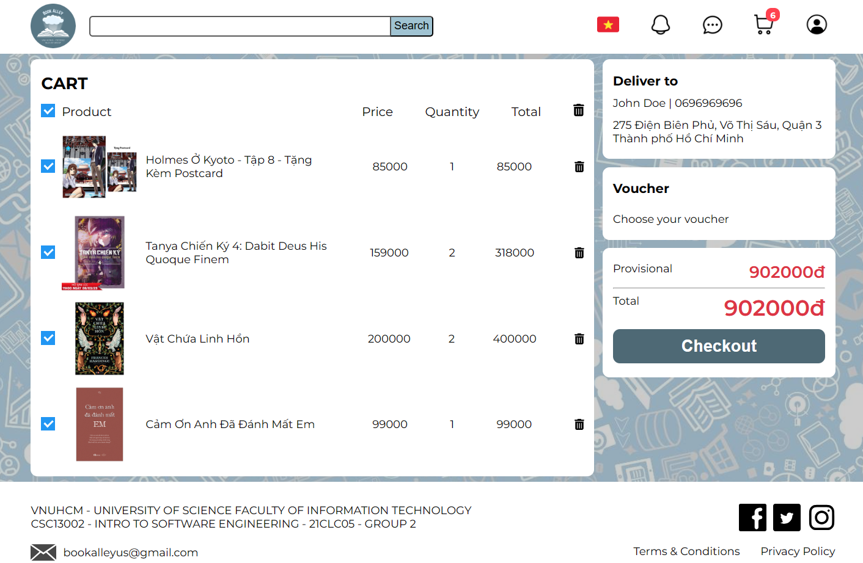

## Assumptions and Dependencies

* Database: The database is one of the most important aspects of the project. Which database is chosen can affect how we store our data. In this project, we’ll be using MongoDB
* Data: Another important aspects is data which will be collected from reliable sources to ensure that we can deliver the highest quality information
* Framework: will decide what environment we’ll be working on to develop the project

# Product Features

| **No.** | **Feature** | **Description** | **Priority** |
| --- | --- | --- | --- |
| 1 | Login | Require the user to login to use the application | High |
| 2 | Register | Allow user to create a new account | High |
| 3 | Forgot password | Allow users to recover their account when they forgot the password | High |
| 4 | Book categorization | Categorize books into many different groups (e.g Horror, Comedy, Science-fiction, etc) | High |
| 5 | Cart | Allow users to add their favorite books into a cart to buy or leave it there for purchase in a later time | High |
| 6 | Recommendation | Recommend the users new books based on their preference from the previous purchase or search | High |
| 7 | Payment methods | Provide the users with multiple secured payment methods for purchasing books | High |
| 8 | Seller Dashboard | Provide booksellers with a dashboard to manage their sales, add new product, track orders, etc | High |
| 9 | Review | Allow customers that have bought the book to leave a rating and review | Medium |
| 10 | User setting | Allow users to customize their account | Medium |
| 11 | Favorite | User can mark a book that they like as a favorite | Medium |

# Non-Functional Requirements

* **Security**: The website must keep user’s information confidential such as password, email, phone number, ID, etc. This is consider the most important requirement
* **Performance**: Page loading must be fast (preferably under 2 seconds) and has the capacity to handle multiple users at once
* **Usability**: The website has to be easy to use even for non technical users.
* **Availability**: The website must be available most of the time (ideally 24/7)
* **Access Control**: Employ strict access controls to limit user access based on roles and permissions to prevent unauthorized data access.
* **Scalability**: Design the system to scale horizontally or vertically to accommodate an increase in users without sacrificing performance.
* **Responsive design**: Ensure the website is responsive and accessible across various screen sizes and devices
* **Caching strategies**: Implement effective caching mechanisms to improve page loading times and reduce server load.